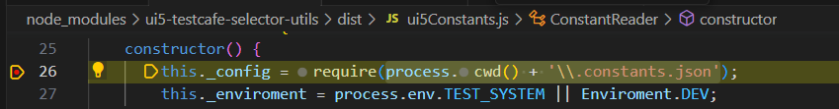

In require:

"C:\\Users\\Rybak\\Desktop\\react\\UI5TestingDemo\\.constants.json"

Loaded into _config

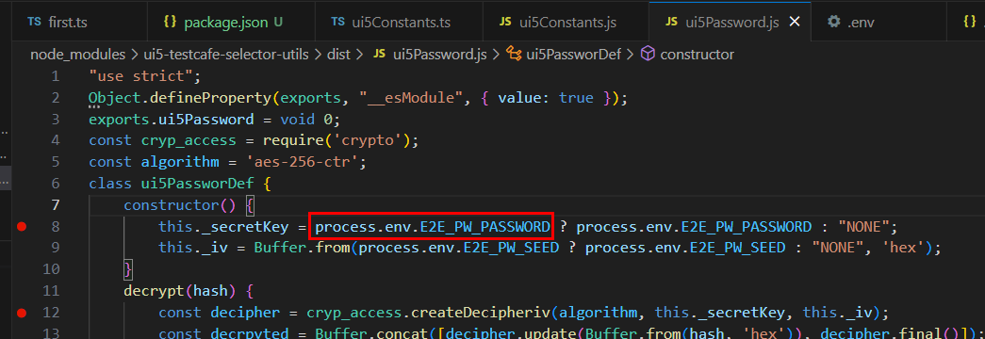

Need .env file

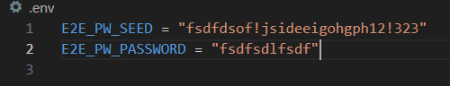

You need “npm i dotenv”

Added line

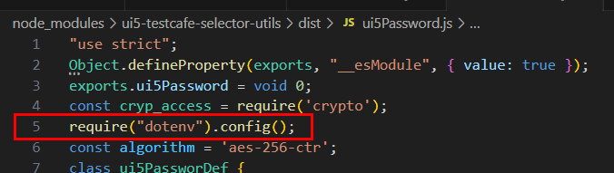

So the ENV variables in constructor are filled.

Also strange, it only uses the constructor, but does not encrypt

Crypto Anpassungen:

<https://www.youtube.com/watch?v=9PL7EK4jXLM>

